Four Colour Theorem (4CT):
Any planar, simple connected graph can be coloured by at most 4 colours.
- First computer assisted proof in mathematics.
- Won’t be going through all 633 cases.
Conjectured in 1852, popularized by De Morgan.
Kempe created a false proof in 1879, disproved in 1890 by Heawood.

- Maximal planar graph. A maximal planar graph will subject the graph to the most colouring restrictions.
  - Every planar graph is contained din maximal planar graph.
- Euler formula:
- # of regions = # edges - # vertices + 2
- Euler's formula for a planar graph: E <= 3V – 6
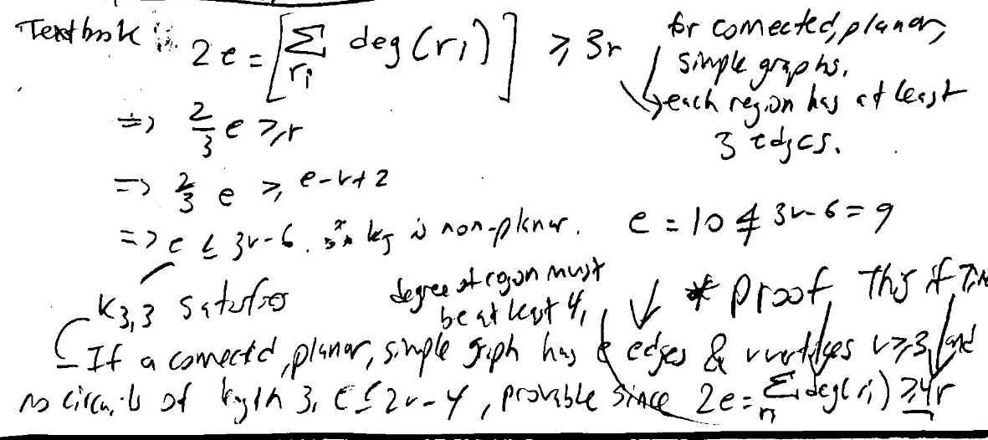
v>=3,
1 region: tree, no forest. E = V-1
Note:
- Think of sphere (sphere is bounded) = plane.
  - Stereographic projection.

E = 3V – 6 for a maximally planar graph.
- Each region has 3 edges from above.
We want the average degree per node, or arity (in a map, not dual graph),
2E = 6V – 12 = Sum of degrees
Therefore, average degree is (6 – 12/v) < 6
- I think every maximally planar graph has a vertex of degree < 6.
Kempe’s proof by induction:
Degree = 2:

Degree = 3:

Kempe Chain:
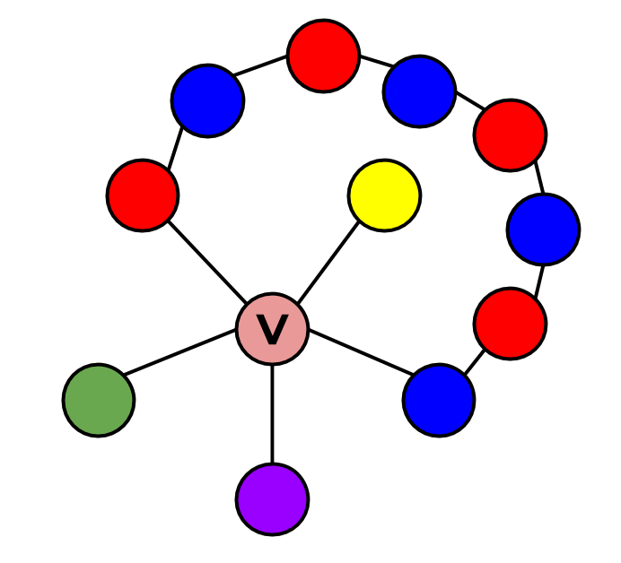

Degree = 4:

If ring is coloured with 3 colours, fill in centre node with remaining colour.
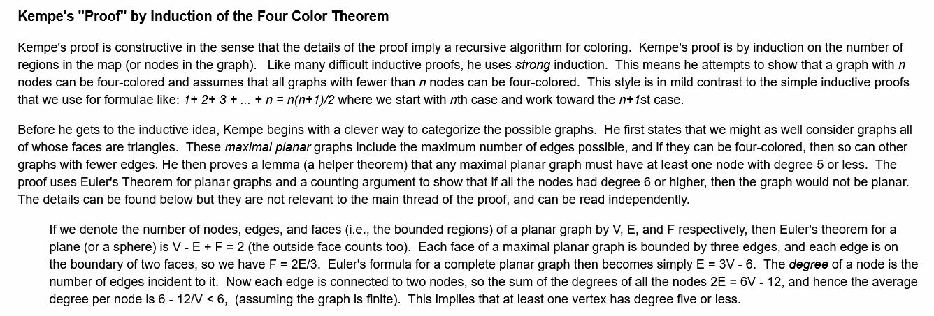
See into the induction.

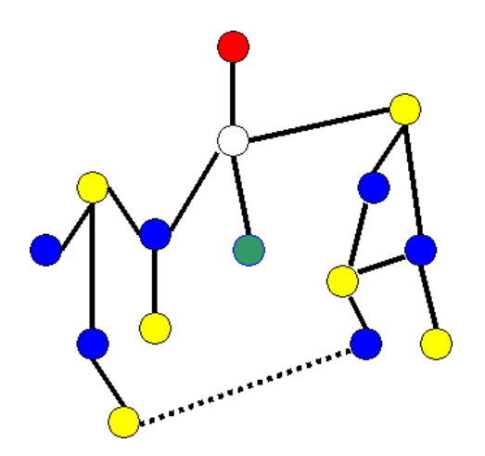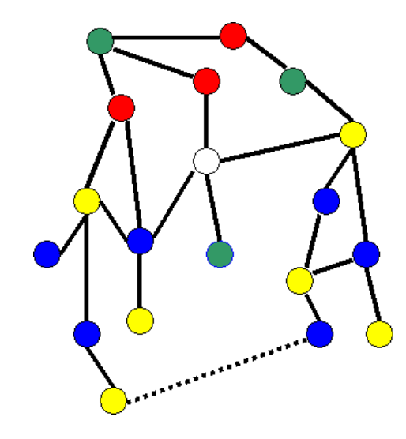
We don’t look at adjacent nodes because it is a worst case.
Degree = 5:

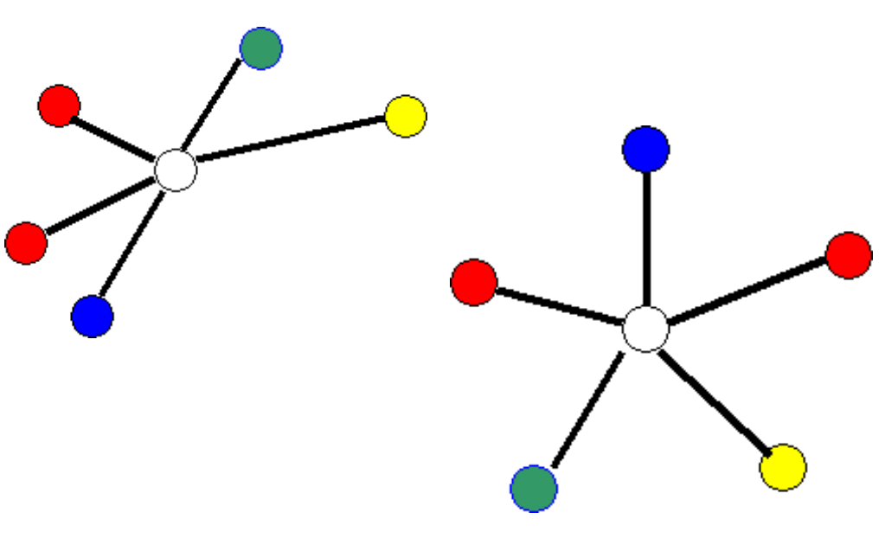
Disproof:
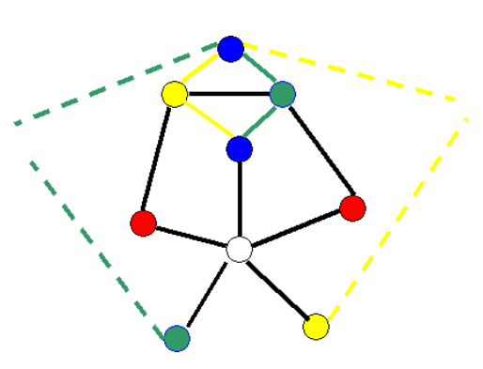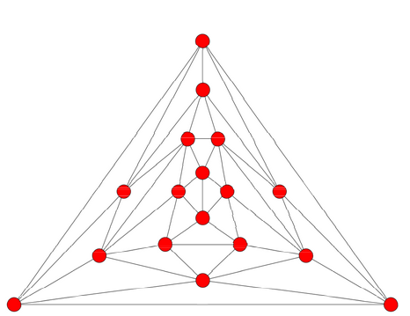

Disproof model on left, Errera graph on right (full disproof model).
https://sites.google.com/site/shaisimonson/professional-page/mathexp/lab4

Minimal counterexample: 6 connected triangulations
Irreducibility:
Unavoidability: A set of configurations that must exists
A triangulation: Maximally planar graph

Next:
Ask about normal subgroups from SYDE 710
Understand the induction more
Irreducibility and unavoidability
AMS and Robertson’s paper
Minimal counterexample (2.1) in Robertson

